**DENTAL SYSTEM COMMON SERVICES MANUAL**

**Check if the client exist in the database**

Use their phone number or refNo given to check

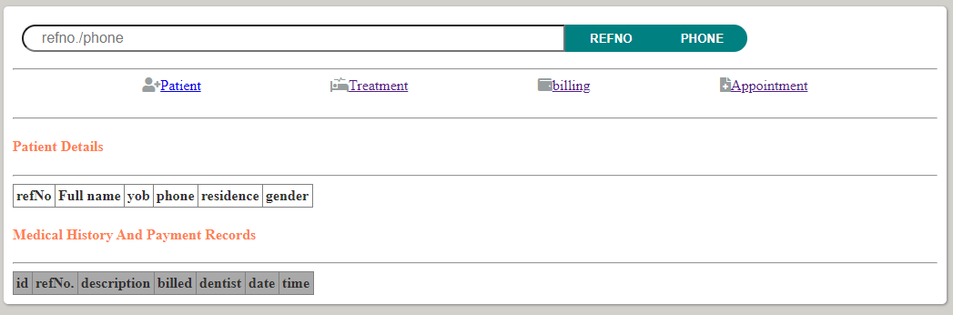If phone, enter the phone number then click phone button otherwise enter the refNo and click refno button and you will be able to see the client dental history and details.

**Always be care full and ensure you are recording the correct data since we are concerned about the clients data security and integrity, you may not be able to edit the information after it is submitted.**

**Register new client into the system**

All clients visiting the facility it is important to have their details regardless of the service.

Steps

1. Click patient
2. Fill in the client details, first name, last name and year of birth are mandatory fields. Click on register before proceed so as to save the client details.

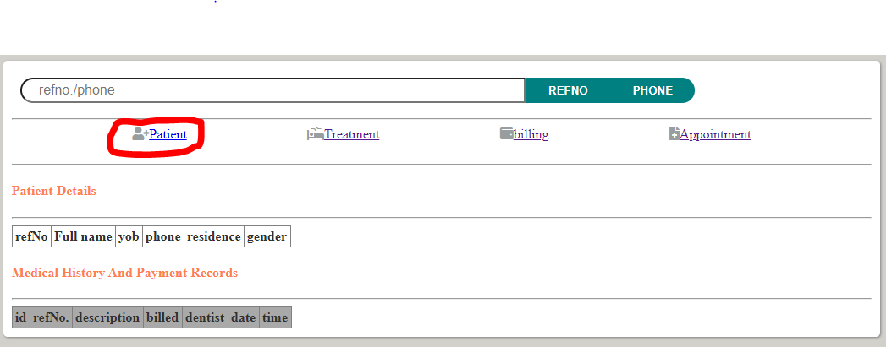

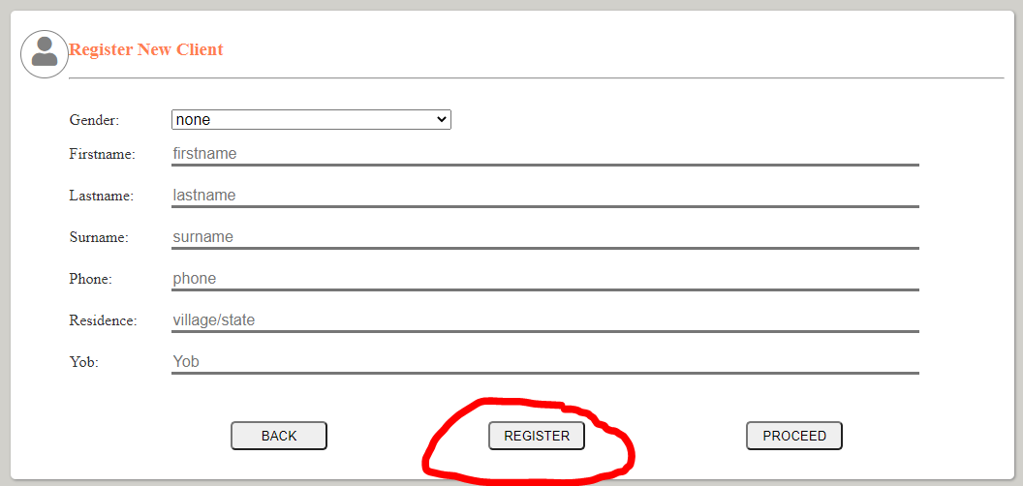

**Diagnosis and Treatment**

This has three categories:

1. Capturing single treatment
2. Capturing multiple treatments
3. Capturing only consultation

You can navigate to DxRx screen through the **side navigation bar** or from **proceed button** on the registration form

**Capturing the single treatment**

1. Enter the refNo of the patient in the refNo field for registered clients and by the default the newly added client refNo will the added automatically.
2. Select the dentition as either permanent or milk teeth, and this will load what the teeth in the category of the selected field.
3. **DX:** allows you to select the possible diagnosis
4. **Rx:** allows you to select the treatment
5. **Dentist field**: allows you to select the dentist who is in charge of the procedure and the assisting personnel in **Assistant field**
6. **After updating the fields click on the save button first to add information to the system and you will be able to see the table on the bottom updated with the information that was saved**

**For multiple treatments**

Simple repeat the same procedure by just updating the necessary field and click save for each treatment

**For consultation**

You don’t need to update all the fields. From the **RX FIELD** select the **consultation** and **click save**

Once you are done Click on the **next button** to take you to the billing screen

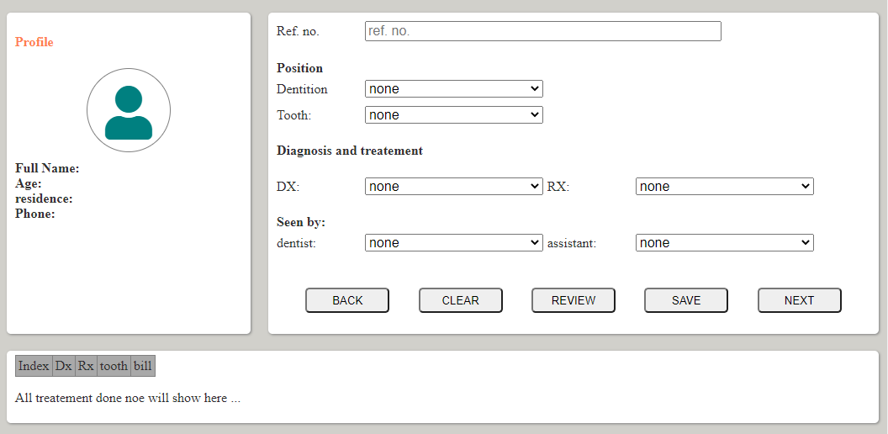

**Billing**

By default the newly added client details will be set and the total bill. But in most cases you may want to serve a client that had been registered before, just update the refNo field and click on **CHECK BUTTON**

Add the amount paid and the system will calculate the rest and if balance is remaining it will be able to show that as well.

Click **transact button** to finish the process.

If client had the balance and the refNo is enter in the field the NAME BALANCE STATUS will be updated on the screen and once the balance is paid click **transaction** **button** then click **clear button**

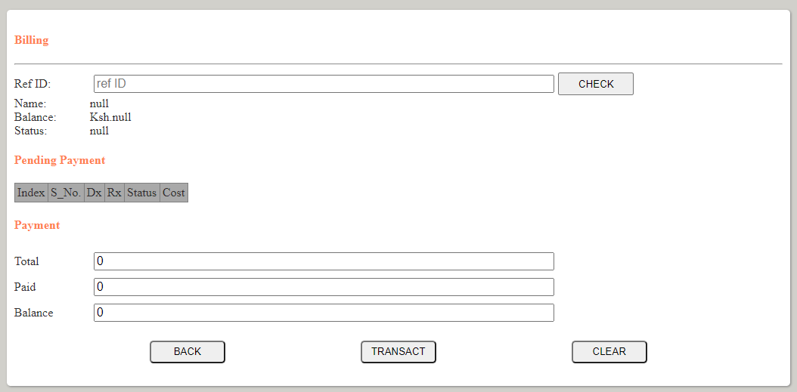

**Record filtering.**

**Navigate** to filter screen from the side bar menu.

For the currents records click on **today button** and they will be listed all while for a given period, select the starting date **FROM:** field and the ending date **TO:** field from the filter bar.

